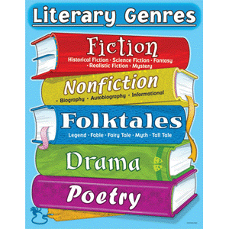

Reading is one of the most essential skills to practice and master. No matter what you do with your life, you must be able to read well in a variety of genres.

Throughout the year, we will read and study many selections together. In addition, you will be reading three independent selections, one per nine weeks, in this order:
- Fiction
- Fiction
- Non-Fiction (a research related selection is recommended)

You may choose to borrow a book from my personal classroom library, from our school library or the local library, download a selection on an E-Reader, etc.

Tentative Timeline (*subject to change):

- Week 2: Books will be selected the second week of each quartile. Start reading!

- Week 3: Continue reading with the goal of finishing your book by week 6.

- Weeks 4-6: Continue reading with the goal of finishing your book by week 6.

- Weeks 7: Draft RAFT proposal. Conference with me. Begin work on your RAFT assignment after approval is given.

- Week 8: Finalize your RAFT assignment. Conference with me if you have questions or problems.

- Week 9: Submit and present your RAFT assignment. Evaluation – Class Presentation of RAFT project

Note: SSR (Silent Sustained Reading) will be given during class when time permits, but there is an expectation that you will work during study hall and at home to meet all independent reading deadlines.

* Independent Reading requirements are subject to change in subsequent nine weeks based on teacher reflection, student feedback and/or scheduling concerns.

